BY ORDER OF  THE COMMANDANT | AIR FORCE INSTITUTE OF TECHNOLOGY  INSTRUCTION 36-116  INSTRUCTION 36-116
 | 1 SEPTEMBER 2002
 | Personnel
 | AFIT QUARTERLY/ANNUAL AWARDS RECOGNITION PROGRAM
COMPLIANCE WITH THIS PUBLICATION IS MANADATORY

NOTICE: This publication is available digitally on the AFIT web site at http://sc.afit.edu/support/SCBI/pubs_local/36-116afiti.pdf. If you lack access, contact your workgroup manager.

OPR: AFIT/CCF Certified by: AFIT MS/CC
Supersedes AFITI 36-116, 11 Jul 2001 Pages: 10

AFITI 36-126, 1 Nov 96 Distribution: F; X
AFITR 900-7, 15 May 90

This instruction establishes policy, responsibilities, and procedures for initiating and implementing the AFIT Quarterly/Annual Awards Recognition Program within the Air Force Institute of Technology.

This instruction is affected by the Privacy Act of 1974. All personal data required to be collected, used, or disseminated by this Instruction must be safeguarded in accordance with AFI 33-332, Air Force Privacy Act Program.

SUMMARY OF REVISION
The military nominations must be submitted on an Air Force Form 1206, Nomination for Award, for all quarterly and annual awards for submission to the next level in a timely manner. Civilian nominations may be submitted on plain bond paper for quarterly awards, but must be submitted on an AF Form 1206 for the annual awards. Sample formats are included in attachments 1 through 4. References to suspenses are removed from this publication. DoD civilians selected as AFIT quarterly/annual award winners are now entitled to a 24-hour time-off award or a $200.00 Notable Achievement Award.
1. Policy. Efficiency and economy of government operations must continue to be a primary objective of each individual. It is management’s responsibility to encourage greater quality, efficiency, and productivity by recognizing superior work and special acts or services accomplished by our people. This award program is administered by AFIT/CCF and applies to all active duty airmen (Amn), noncommissioned officers (NCO), senior noncommissioned officers (SNCO), company grade officers (CGO), and Department of Defense (DoD) civilians assigned to AFIT.

2. Eligibility. Any military member (regardless of branch of service) or DoD civilian assigned to AFIT is eligible for nomination to the AFIT Quarterly/Annual program.

3. Period. The period for the quarterly programs are: 1 January through 31 March; 1 April through 30 June; 1 July through 30 September; 1 October through 31 December. The period for the annual program is 1 January through 31 December.

4. Award Categories. The award categories are as follows:

4.1. Airman of the Quarter/Year: E-1 through E-4

4.2. NCO of the Quarter/Year: E-5 and E-6

4.3. SNCO of the Quarter/Year: E-7 through E-9

4.4. CGO of the Quarter/Year: O-1 through O-3

4.5. Civilian of the Quarter/Year Category I: GS/WG-1 through 6

4.6. Civilian of the Quarter/Year Category II: GS/WG-7 through 11

4.7. Civilian of the Quarter/Year Category III: GS/WG-12 and above

Note: Personnel compete in the category in which they held a grade for the longest period of time during the nomination period.

5. Responsibilities.

5.1. Deans and Directors.

5.1.1. Nominate eligible personnel to AFIT/CCF and ensure availability of military nominees to meet AFIT selection boards. Total score is calculated by adding the interview and package scores. Military personnel who are TDY, on quarters, or emergency leave (during the board) will be given a score that is the average of those who have been interviewed. Military members on ordinary leave will not be eligible to compete.

5.1.2. Comply with nomination criteria identified in attachments 1 through 4 of this instruction when submitting a nomination for quarterly or annual award.

5.1.3. Ensure supervisors are aware of the awards program and deserving personnel are nominated for recognition.

5.2. AFIT/CCF

5.2.1. Monitor and serve as the focal point for the quarterly and annual awards programs. Ensure publicity for AFIT awards programs.

5.2.2. Ensure each nomination received meets the guidelines established in this instruction.

5.2.3. Establish board-convening dates based on Team Wright-Patterson Awards Program. Publish these dates on an annual basis as an attachment to this instruction.

5.2.4. Request board members from any school or directorate to create selection boards.

5.2.5. Collect nominations, set up packages, and brief all board members on process.

5.2.6. Reserve two locations to hold interview boards. One location will be used for the discussion/scoring and selection of the DoD civilian packages followed by the company grade officer interviews. The second location will be used for the enlisted board interviews.

5.2.7. Contact member and supervisor advising them of date, time, and place of board.

5.2.8. Upon final board results, prepare minutes for signature of the AFIT squadron commander and commandant. Maintain file copy of minutes for historical records.

5.2.9. Provide selectees with information for recognition board photograph; rotate photographs quarterly.

5.2.10. Procure engraved plaques/trophies and assist with presentations at Commandant's Call.

6. Procedures.

6.1. All nominations must be submitted through the respective dean or director to the AFIT First Sergeant. Schools/directorates cannot nominate more than one assigned person for each category for quarterly nominations. Schools/directorates may nominate up to two personnel in the military categories for the annual awards program. The board may choose separate nominees in each annual military category for submission to the Team Wright-Patterson and the Air University and 12 Outstanding Airmen of the Year Programs. DoD civilians annual award winners for AFIT compete at Air University only.
6.2. Quarterly nomination format

6.2.1. Quarterly nominations for DoD civilians will be done using plain bond paper with the applicable format and headings per attachment 3 of this instruction. The justification should be in bullet format and not exceed two pages.

6.2.2. Quarterly nominations for military members will be done using the Air Force Form 1206 with the applicable format and headings per attachments 1 and 2 of this instruction. The justification should be in bullet format and not exceed one page.

6.3. Annual nomination format

6.3.1. Annual nominations for civilians must be done on Air Force Form 1206 per attachment 4 of this instruction. Annual nominees need not be a previous quarterly winner, but must have been assigned to AFIT at least 6 months or more during the 12-month period. The justification should be in bullet format and not exceed two pages.

6.3.2. Annual nominations for military members must be done on Air Force Form 1206 per ASC Instruction 36-2802. Annual nominees need not be a previous quarterly winner, but must have been assigned to AFIT at least 6 months or more during the 12-month period. The justification should be in bullet format and not exceed two pages.

6.4. Nominations will only contain facts and achievements that occurred during nomination period.

7. Selection Board.

7.1. Board makeup.

7.1.1 The quarterly/annual DoD civilian board will consist of one O-5, or senior O-4, as president of the board, two O-4s and two civilians, GS-12 and above.

7.1.2. The quarterly/annual CGO board will consist of one O-5, or senior O-4, as president of the board, and two O-4s. (These officers will be the same ones that make up the civilian board.)

7.1.3. The quarterly/annual enlisted board will consist of an SNCO as president of the board. The NCO board will require two more senior NCOs and the Airman board will require one NCO and one senior NCO. A board recorder will be assigned to meet board nominees and provide them with direction for successful reporting to the board. The recorder will act as the liaison between nominees and the board president.
7.2. Board process.

7.2.1. Copies of award nominations, score sheets, and interview schedule will be provided to all board members at least one day prior to the board. Board members will evaluate each nominee and or nomination in a fair and equitable manner.

7.2.2. Board members will forward three opinionated questions to the board president two days prior to the board convening. Once the board convenes, the board president will provide the members with two approved questions to be asked per para 7.2.5. Questions should be military-related.

7.2.3. The civilian and CGO board members will score and discuss the civilian nominations to determine the AFIT selectee for each of the three civilian categories.

7.2.4. The enlisted board will discuss any questions on the written nominations and begin with the Airman, NCO, and SNCO board interviews.

7.2.5. All nominees (military boards) will be asked two specific and opinionated questions from each board member (not the board president). These questions should be objective and designed to allow the nominee an opportunity to talk about the subject to evaluate communication skills rather than knowledge of the subject.

7.2.6. Board members will score the nominees using the score sheets and criteria provided.

7.2.7. After all nominees have met the board, the board members discuss, based on scoring criteria, any major differences. All board members are voting members and the board president will resolve any differences between board members.

7.2.8. Upon conclusion of the board, the board president will present to the First Sergeant the board's final selections. All written nominations, score sheets, and notes must be returned to the First Sergeant upon completion of the board.

7.2.9. AFIT military selectees will compete in the Team Wright-Patterson Quarterly/Annual Awards Program. Supervisors will submit to the First Sergeant an electronic AF Form 1206 by the suspense date directed. The AF Form 1206 must comply with ASC Instruction 36-2802 for submittal to the Team WPAFB Awards Board.

7.2.10. The annual AFIT competition will be conducted by a single board and only award nomination packages will be reviewed. This will ensure the strongest packages are forwarded to AU and AETC for next-level annual competition. The AFIT annual military selectees will meet a mock board established by the First Sergeant to prepare for Team Wright-Patterson Interviews Board.
8. Awards and Honors.

8.1. After notification of their selection, the selectees' names and pictures will be posted on the "AFIT's Finest" board in the lobby of Bldg 642 until the next quarter.

8.2. Award winners will receive their awards at the next Commandant's Call.

8.3. Award winners will receive a plaque and a certificate of commendation. Additionally, military award winners will receive a 3-day pass. DoD civilian award winners will receive their choice of either a 24-hour time-off award or a $200.00 Notable Achievement Award.

MICHAEL L. HEIL, Colonel, USAF
Commandant
Air Force Institute of Technology
Attachment 1

NOMINATION FORMAT REQUIREMENTS FOR ENLISTED AWARDS

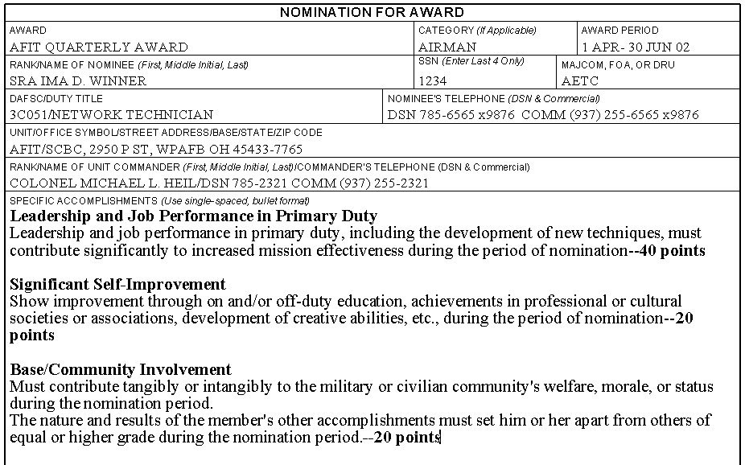

Note: Do not include point value in headings; it is printed here for reference only. Nominations for AFIT military awards will be on AF Form 1206 and limited to one single-spaced page for quarterly nominations and two single-spaced pages for annual nominations. All nominations must be in bullet format and should include specific facts and examples showing the individual is exceptional with achievements that distinguish the nominee from his/her peers. Bullets should explain the action (what did he/she do) results (what happened because of what he/she did) and impact (what was the significant effect on office, school, directorate, AFIT, base, etc.).
Attachment 2

NOMINATION FORMAT REQUIREMENTS FOR OFFICER AWARDS

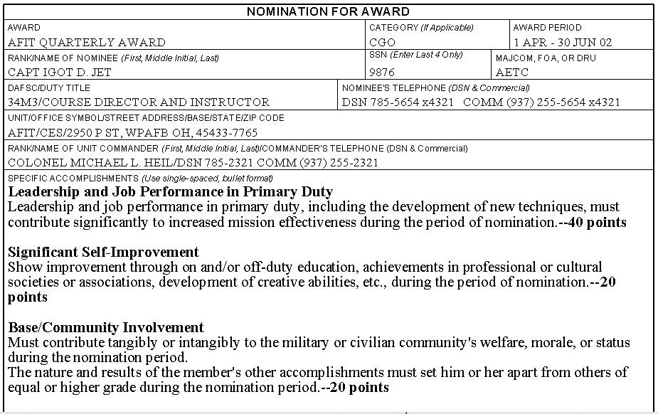

Note: Do not include point value in headings; it is printed here for reference only. Nominations for AFIT military awards will be on AF Form 1206 and limited to one single-spaced page for quarterly nominations and two single-spaced pages for annual nominations. All nominations must be in bullet format and should include specific facts and examples showing the individual is exceptional with achievements that distinguish the nominee from his/her peers. Bullets should explain the action (what did he/she do) results (what happened because of what he/she did) and impact (what was the significant effect on office, school, directorate, AFIT, base, etc.).

Attachment 3

NOMINATION FORMAT REQUIREMENTS FOR CIVILIAN QUARTERLY AWARDS

(Example for GS/WG-1-6, GS/WG-7-11, and GS/WG-12 and Above)

NOMINATION FOR AFIT CIVILIAN OF THE QUARTER, GS-xx
FIRST QUARTER 2001
ACCOMPLISHMENTS OF MS. JANE DOE

Ms. Jane Doe, GS-11
AFIT/CEA
Supervisor: Major John Buck Duty Phone: 5-6565 x 4347

Contributions to Improve Work Center Operations/Special Act

Include the employee’s significant achievements, that displayed initiative, perseverance, devotion to duty, improvements to methods or procedures, eliminating or minimizing safety hazards, increased productivity, saved time, money or resources, and improved customer service—55 points

Other Noteworthy Achievements

Include other comments not covered in the above subject area.—15 points

Participation in Community Activities

Include the degree of involvement the employee had with the community—15 points

Development

Include all self-development activities employee completed or participated in—15 points

Note: Nominations for AFIT quarterly civilian awards will be submitted on plain bond paper limited to two single-spaced pages. Use bullet format (may use sub-bullets also). Page margins should be 1” using 12-point font size. To improve the opportunity of your nomination, it is recommended that the write-up be professional in appearance, contain “reader-friendly” information about the nominee’s accomplishments, and clearly describe only those accomplishments attributable to the nominee within the specified period. Each achievement category noted above must be identified and addressed. Candidates who reflect solid achievements in each category are the most competitive.

Attachment 4

NOMINATION FORMAT REQUIREMENTS FOR CIVILIAN ANNUAL AWARDS

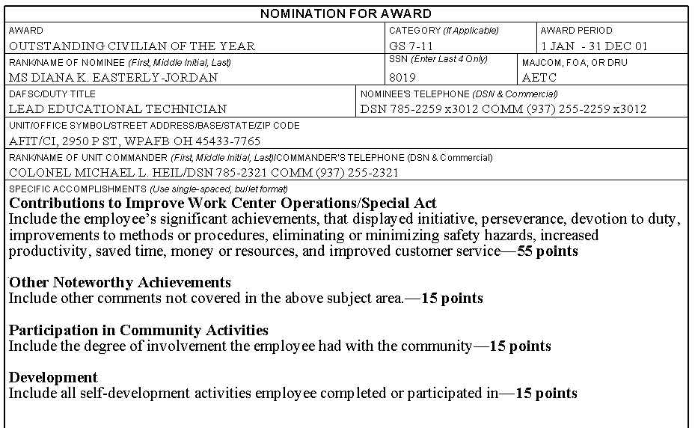

Note: Do not include point value in headings; it is printed here for reference only. Nominations for AFIT civilian annual awards will be on AF Form 1206 and limited to two single-spaced pages. All nominations must be in bullet format and should include specific facts and examples that show the individual is exceptional with achievements that distinguish the nominee from his/her peers. Bullets should explain the action (what did he/she do) results (what happened because of what he/she did) and impact (what was the significant effect on office, school, directorate, AFIT, base, etc.).

